**Analyzing the Neighborhoods in Mumbai for Starting a Restaurant**

Applied Data Science Capstone Project

By: Jean Charles

Date: July 13, 2024

Table of Contents

Introduction 2

Data Collection 3

Neighborhoods Data 3

Geographical Coordinates 4

Venue Data 6

Methodology 7

Data Visualization 7

Feature Extraction 8

Unsupervised Learning 10

Results 11

Discussion 14

Conclusion 15

Final Comments 15

# Introduction

Mumbai, the financial capital of India, is among the most densely populated cities globally. Located on India's west coast, it attracts significant tourism from around the world each year. Having grown up in Mumbai, I have a deep affection for the city. It stands as a major global hub, characterized by its remarkable diversity, with residents from various ethnic backgrounds. This multicultural fabric has introduced a wide range of international cuisines to the city.

Given India's general passion for food, and my personal enthusiasm for exploring different cuisines and flavors, this project aims to analyse Mumbai's neighbourhoods to identify potential locations for opening a restaurant. The findings will be valuable for business owners and entrepreneurs seeking to invest in the restaurant industry in Mumbai. The primary objective of this project is to meticulously analyse relevant data to provide informed recommendations for stakeholders.

# Data Collection

## The following data is required for the project:

## 1. **Neighbourhood Data of Mumbai**

## 2. **Geographical Coordinates of Mumbai and All Neighbourhoods in Mumbai**

## 3. **Venue Data for Neighbourhoods in Mumbai**Neighbourhoods Data

The data for the neighbourhoods in Mumbai was scraped from [this Wikipedia page] (https://en.wikipedia.org/wiki/List_of_neighborhoods_in_Mumbai). The data is read into a Pandas Data Frame using the `read HTML () ` method. The main reason for this approach is that the Wikipedia page provides a comprehensive and detailed table that can be easily scraped using Pandas' `read_html()` method. Figure 1 displays the top 10 rows of the DataFrame.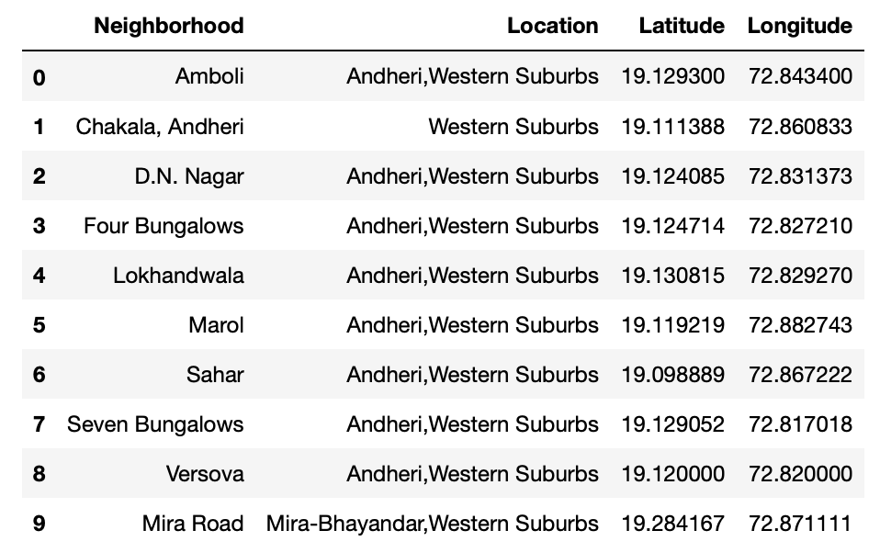

Figure 1: Top 10 rows of Mumbai neighborhoods data scraped from Wikipedia.

## Geographical Coordinates

The geographical coordinates for Mumbai were retrieved using the GeoPy library in Python. These coordinates are essential for generating a map of Mumbai using the Folium library in Python. Figure 2 presents the code used to obtain the geographical coordinates of Mumbai.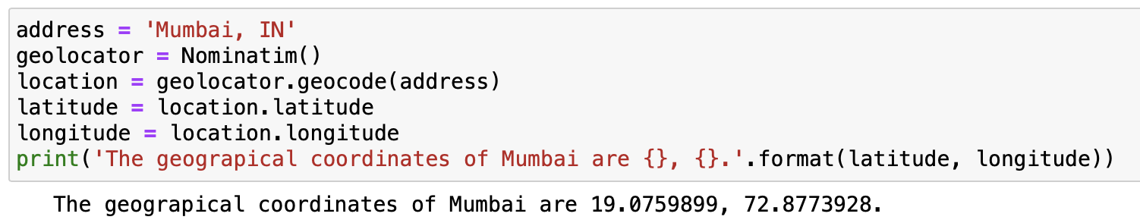

Figure 2: Obtaining geographical coordinates of Mumbai.

The geocoder library in Python was utilized to acquire latitude and longitude data for various neighbourhoods in Mumbai. These coordinates were compared with those provided on Wikipedia within our Data Frame. If the absolute difference exceeded 0.001, the coordinates from geocoder were used to refine our dataset. Subsequently, these refined coordinates were employed for plotting neighbourhoods using the Folium library in Python. Figure 3 displays the comparison between the coordinates obtained from Wikipedia ('Latitude', 'Longitude') and those obtained from geocoder ('Latitude1', 'Longitude1'). It also presents the absolute differences between the two latitude columns ('Latdiff') and the two longitude columns ('Longdiff'). Only the top 10 rows are shown.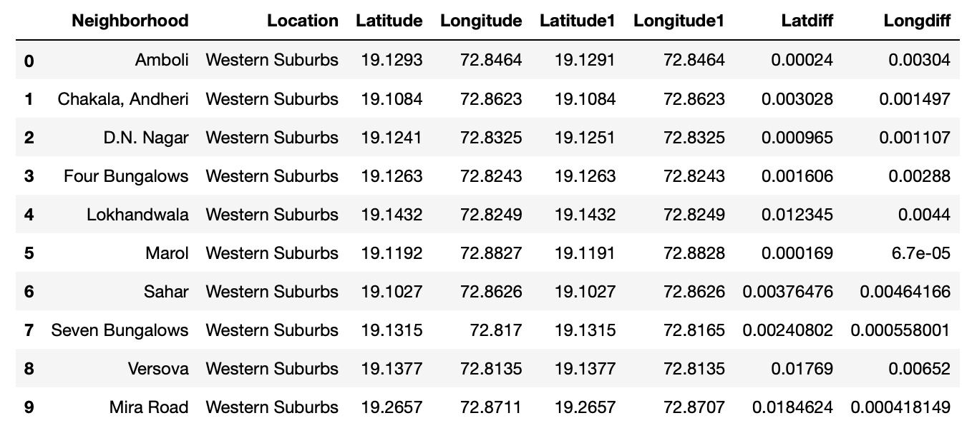

Figure 3: Absolute difference between latitude and longitude values obtained from Wikipedia and Geocoder.

Figure 4 displays the top 10 rows of the finalized Mumbai neighbourhoods DataFrame. This DataFrame includes refined latitude and longitude values obtained after comparing and replacing coordinates from the geocoder library where necessary. Additionally, unnecessary columns have been dropped for clarity and focus.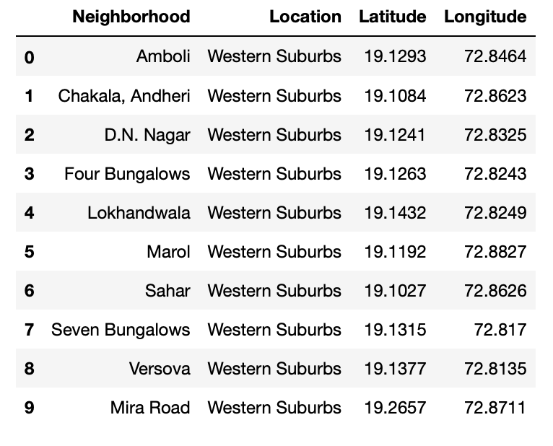

Figure 4: Final Mumbai neighborhoods dataframe.

## Venue Data

Venue data was collected using the Foursquare API, providing recommendations for all neighbourhoods in Mumbai. This dataset serves to analyse popular venues across neighbourhoods and construct an unsupervised learning model for clustering. Each neighbourhood’s venue recommendations were retrieved with a limit of 200 venues per neighbourhood and within a radius of 1 km from the neighbourhood’s geographical coordinates. Figure 5 displays the top 10 rows of cleaned data obtained from the Foursquare API.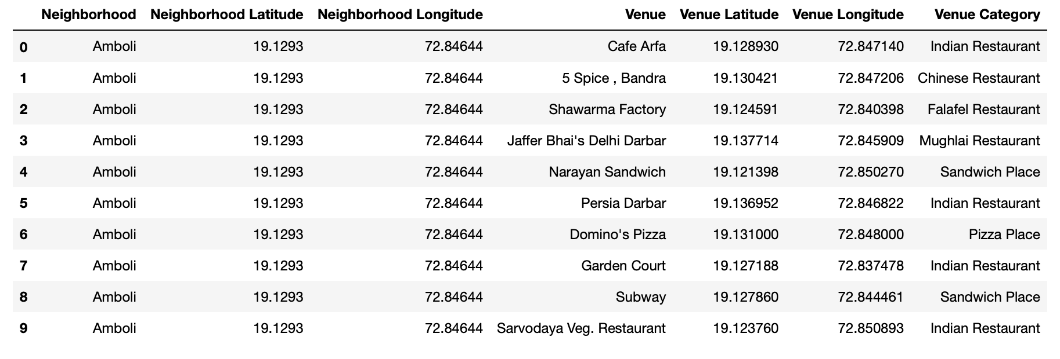

Figure 5: Data obtained from Foursquare API after cleaning.

# Methodology

This section provides details for the methodology used in the project.

## Data Visualization

Figure 6 presents a bar plot illustrating the distribution of neighbourhoods across different locations in Mumbai. This visualization provides a basic understanding of the number of neighbourhoods in each area of the city.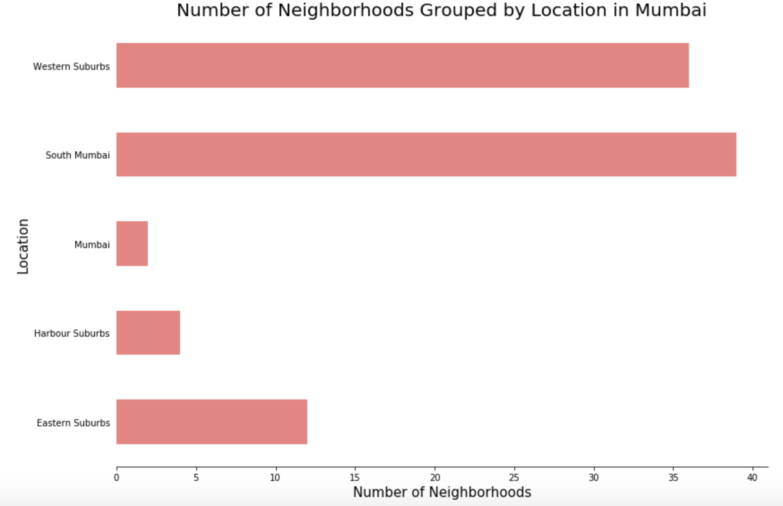

Figure 6: Number of neighbourhoods grouped by location.

Figure 7 displays a map generated using Folium, illustrating the distribution of neighbourhoods across Mumbai. The map highlights how neighbourhoods are spread throughout the city, including those located at the outskirts categorized simply as "Mumbai."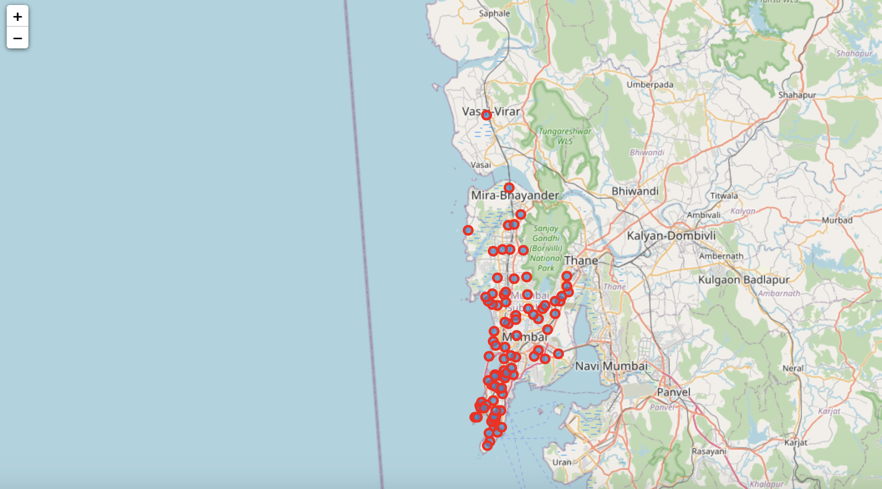

Figure 7: Depicting the neighbourhood spread across Mumbai.

## Feature Extraction

Feature extraction involved transforming the Foursquare API data (referenced in Figure 5) to prepare for building the unsupervised learning model. This process required converting the "Venue Category" column into a numeric format suitable for modelling. One-hot Encoding was employed for this purpose, where each unique venue category was converted into a separate column. A value of 1 was assigned to a neighbourhood’s row in a specific category column if it included venues from that category. column and if a neighbourhood venue does not belong to the category, the value would be 0. This process was repeated A sparse matrix was generated from all venues across neighbourhoods using One-hot Encoding, resulting in a Data Frame where each neighbourhood’s row contains columns representing unique venue categories with values of 1 or 0 indicating presence or absence of venues in those categories. Subsequently, the Data Frame was grouped by neighbourhood name, and the average value across all categories was computed. Figure 8 presents the top 10 rows of this averaged DataFrame.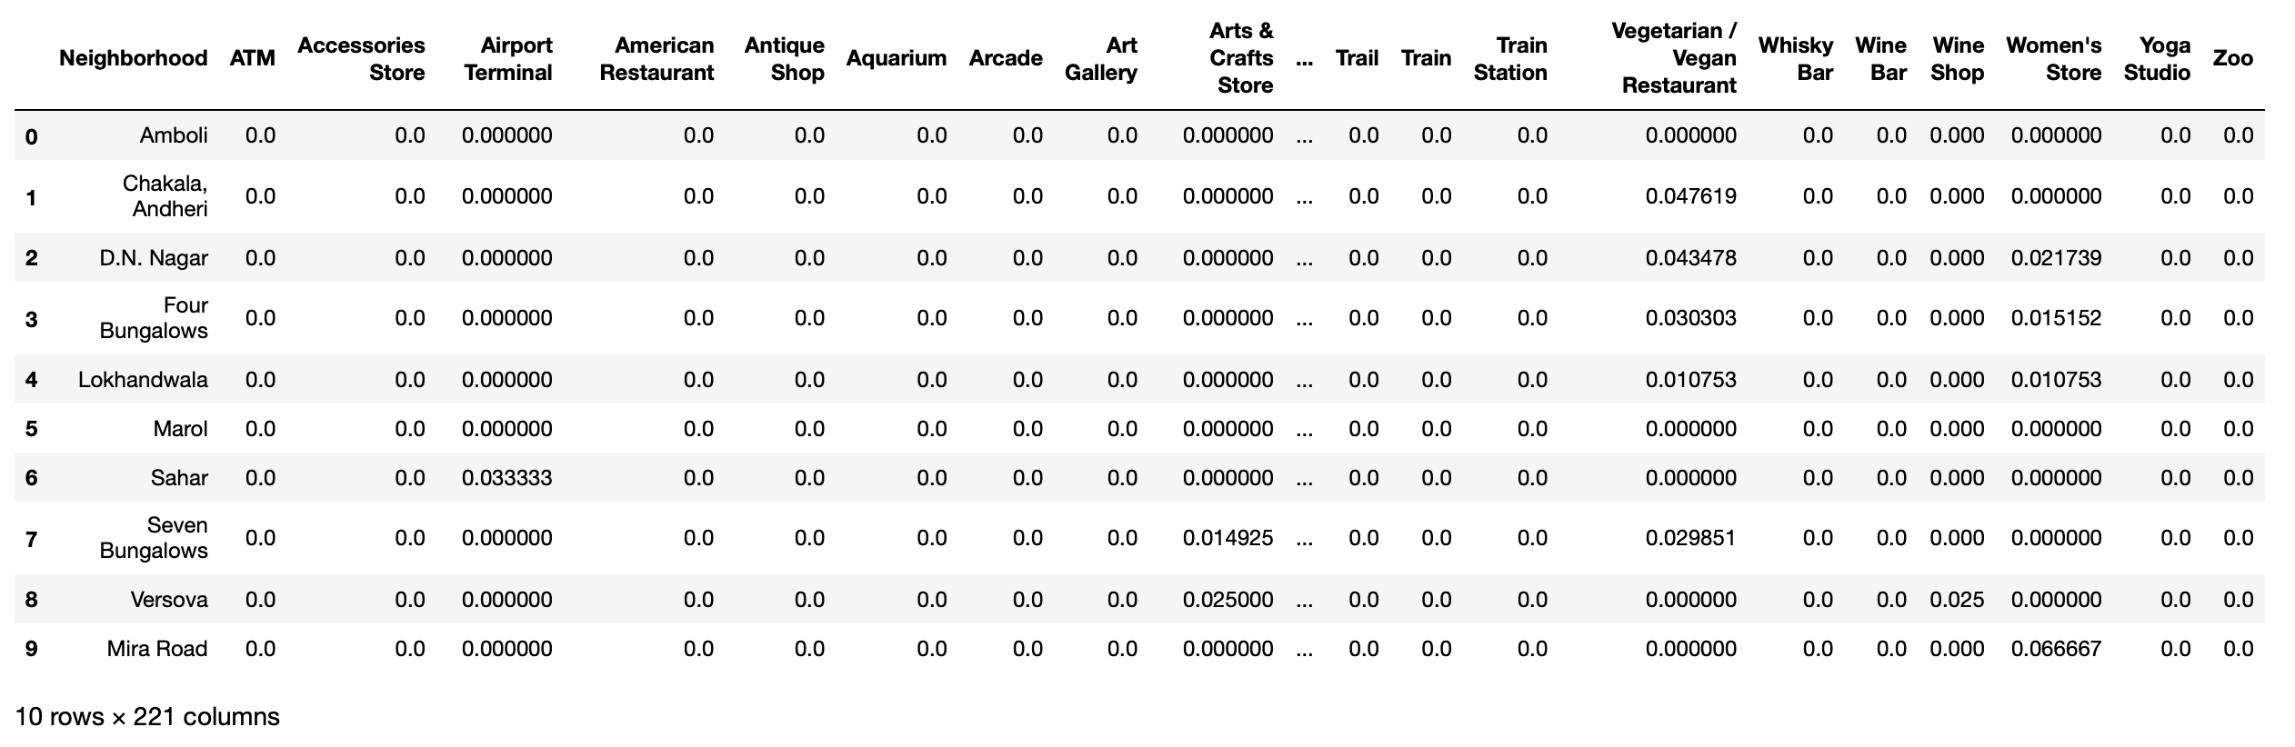

Figure 8: One-hot Encoding resulting dataframe.

### Feature Extraction

To prepare for the unsupervised learning model, a sparse matrix was created using One-hot Encoding across all neighbourhoods and venue categories from the Foursquare API data (as depicted in Figure 5). Each neighbourhood’s row in this matrix indicates the presence (1) or absence (0) of venues in various categories. After grouping by neighbourhood name, the average presence across categories was computed, resulting in a DataFrame (Figure 8) where most values are 0 due to the diversity of venue categories and varying presence in neighbourhoods.

### Top 10 Common Venues DataFrame

Additionally, a DataFrame was constructed listing the top 10 most frequent venue categories across all neighbourhoods. Although not directly part of Feature Extraction, this DataFrame provides insight into common venue types and will be used later to integrate findings from the unsupervised learning model. Figure 9 displays the top 10 rows of this DataFrame.

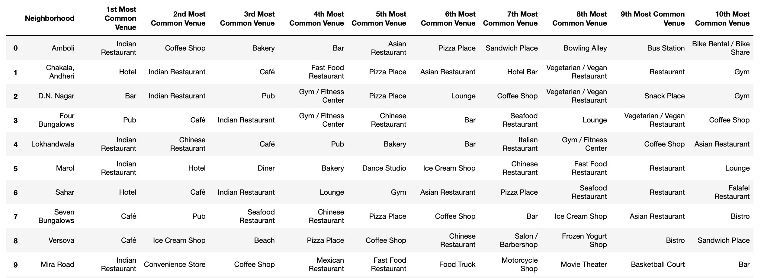

Figure 9: Top 10 most common venues for neighborhoods.

# Unsupervised Learning

K-means, an unsupervised learning technique, was employed to cluster neighbourhoods based on nearby venue categories. An essential step in this process was determining the optimal number of clusters. This was achieved using the Silhouette score, calculated across a range of clusters from 2 to 15. Figure 10 presents the resulting number of clusters identified and their corresponding Silhouette scores, aiding in the selection of the optimal clustering configuration.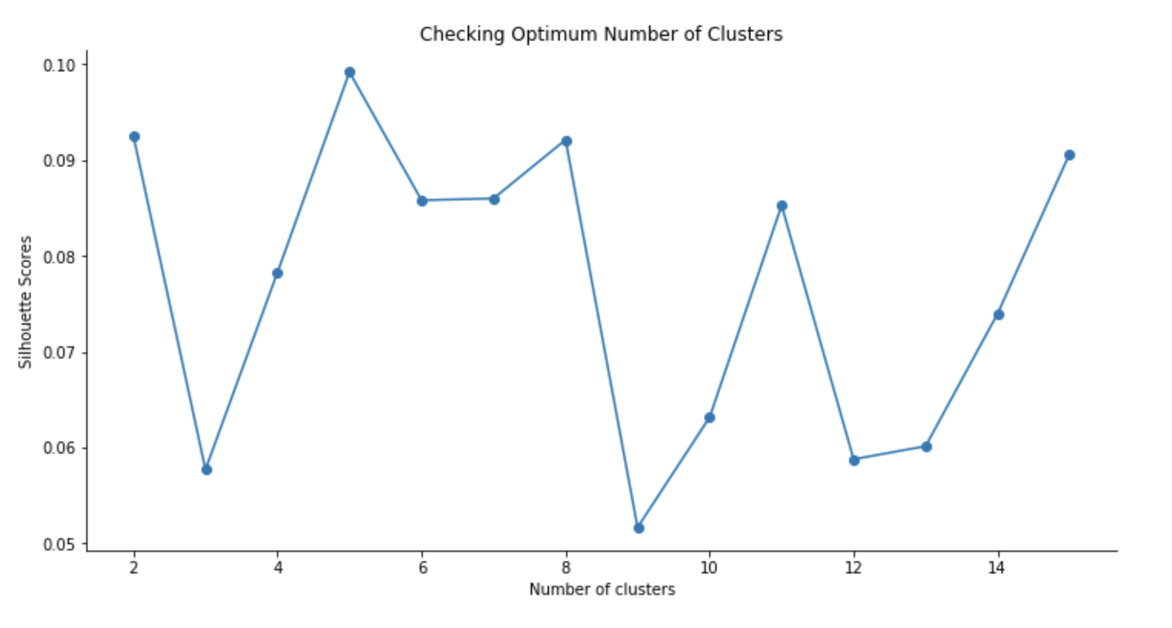

Figure 10: Silhouette scores for different number of clusters.

While the Silhouette scores indicate moderate clustering quality across various k-values, it is apparent that higher scores are not achieved consistently. Nonetheless, the data will be clustered using the k-means algorithm. Based on the analysis shown in Figure 10, 5 clusters will be utilized as it yields the highest Silhouette score within the range evaluated. This choice aims to achieve the most effective clustering of neighbourhoods based on venue categories.

# Results

Using the k-means clustering algorithm, neighborhoods in Mumbai were grouped into clusters based on their nearby venue categories. Each neighborhood was assigned a cluster label representative of its cluster assignment. These cluster labels were integrated into the DataFrame from Figure 9, along with the Location, Latitude, and Longitude columns, providing a comprehensive summary of the clustering results

Figure 11: Clustering neighbourhoods in Mumbai.

To delve deeper into specific clusters, neighbourhoods within each cluster were extracted based on their assigned cluster labels. Below are details for each cluster, showcasing neighbourhoods within clusters that contain a significant number of neighbourhoods. Each cluster's details are presented with a limit of 10 rows for clusters with extensive neighbourhood representation.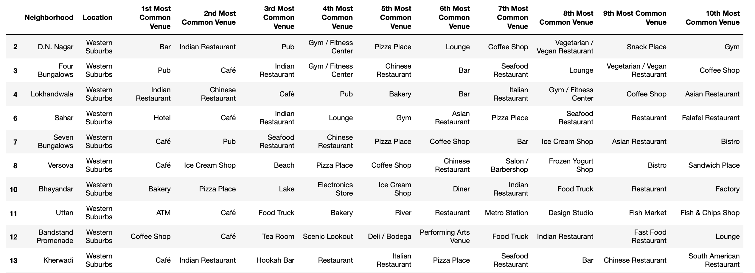

Figure 12: Cluster 1.

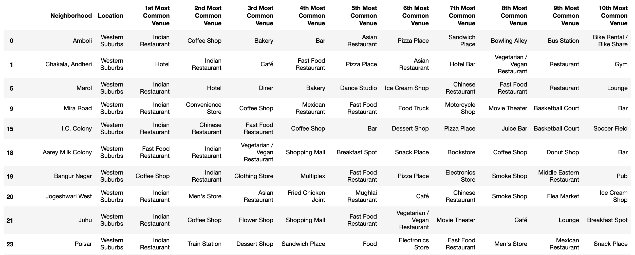

Figure 13: Cluster 2.

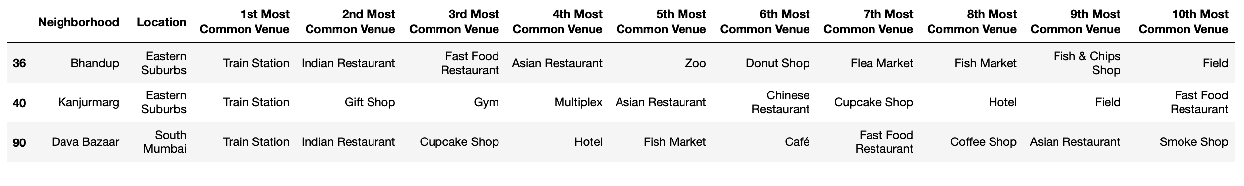

Figure 14: Cluster 3.



Figure 15: Cluster 4.



Figure 16: Cluster 5.

Figure 17 depicts a map of Mumbai where neighbourhoods are plotted with markers of different colours to distinguish between clusters identified through the k-means clustering model. This visualization provides an overview of how neighbourhoods are spatially distributed across Mumbai, grouped according to their similarities in nearby venue categories as determined by the clustering analysis.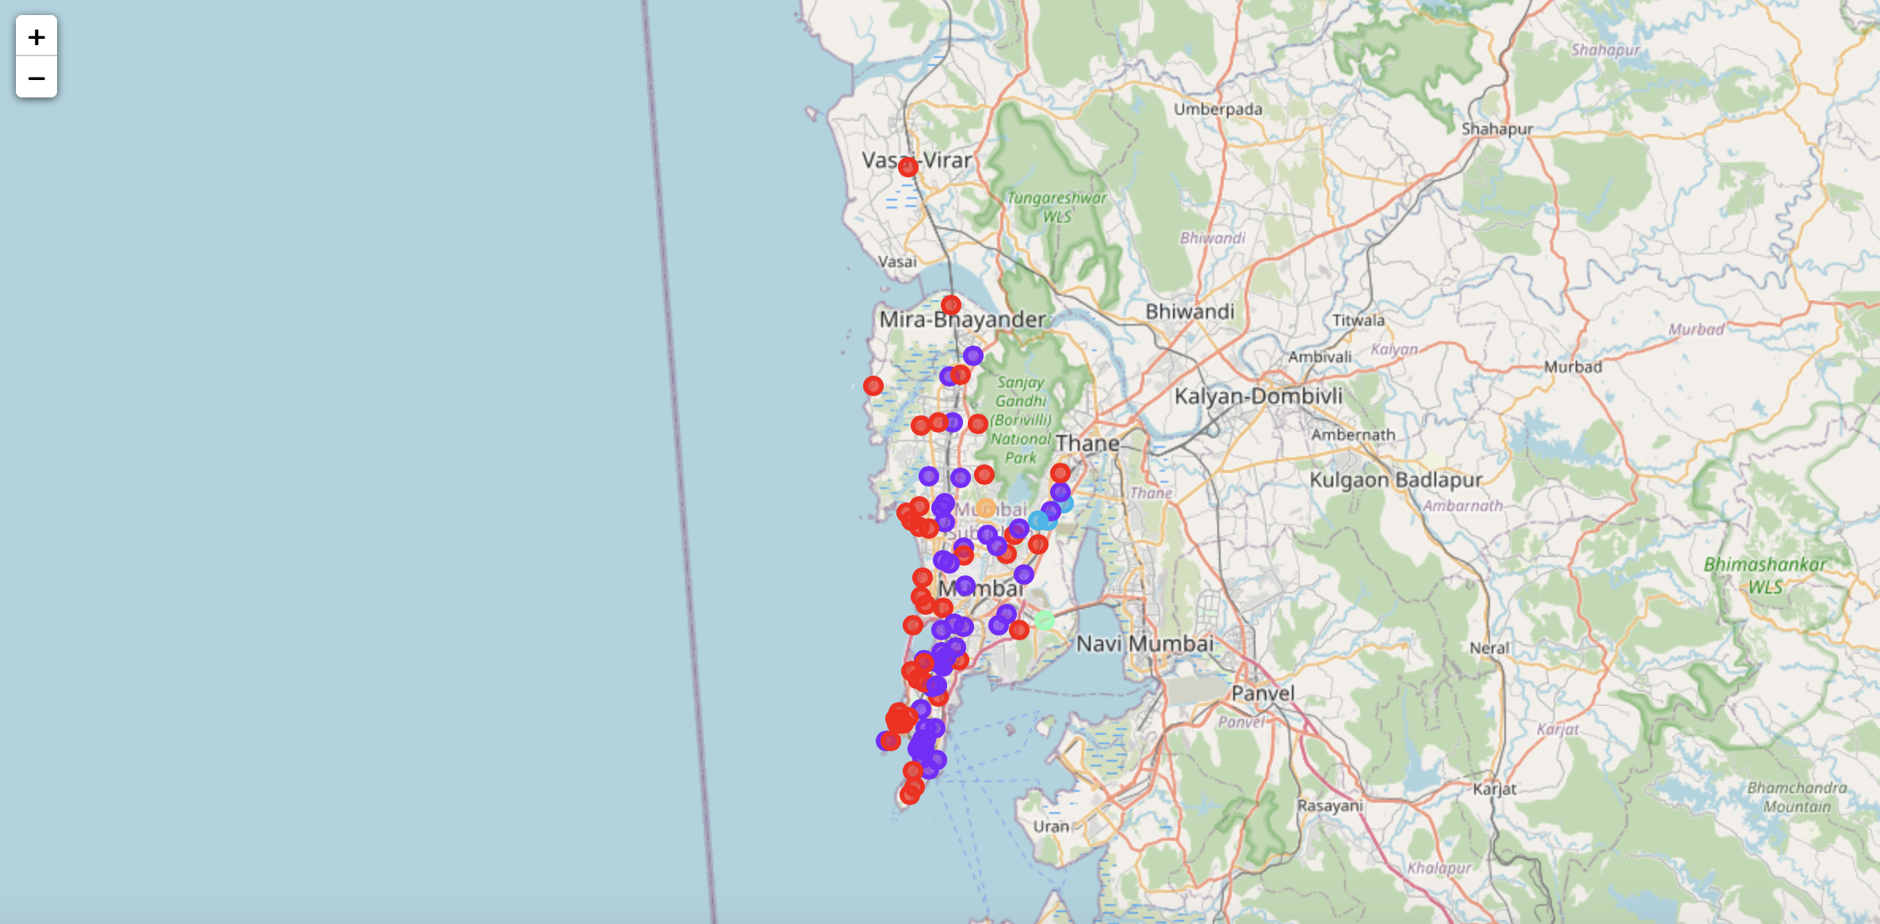

Figure 17: Visualizing the clustering of neighbourhoods in Mumbai.

# Discussion

Upon analysing the five clusters generated from the k-means clustering:

* **Clusters 3, 4, and 5**: These clusters exhibit a low percentage of restaurants, hotels, cafes, and pubs among their top 10 common venues. Instead, they are characterized by venues such as train stations, bus stations, fish markets, gyms, performing arts venues, and smoke shops. These neighbourhoods are less suitable for opening a new restaurant.
* **Clusters 1 and 2**: These clusters feature a higher concentration of restaurants, hotels, multiplexes, cafes, bars, and other food joints in their top 10 common venues. They are therefore more conducive to starting a new restaurant.

Comparing clusters 1 and 2:

* **Cluster 1**: Neighbourhoods here show a diverse range of food joints including restaurants, tea rooms, bakeries, cafes, steakhouses, and pubs. They also feature a variety of cuisines such as Japanese, Indian, Chinese, Italian, and seafood restaurants.
* **Cluster 2**: While Indian Restaurants dominate as the most common venue in cluster 2, further inspection reveals a mix of other venues like soccer fields, flea markets, smoke shops, gyms, train stations, dance studios, music stores, and cosmetics shops.

**Recommendation**:

Given the higher diversity and concentration of food-related venues in cluster 1, it is recommended to open the new restaurant in neighbourhoods belonging to this cluster.

### Mapping Recommended Neighbourhoods

Figure 18 displays a map highlighting neighbourhoods from cluster 1, ideal for opening a new restaurant based on their favourable venue profile.

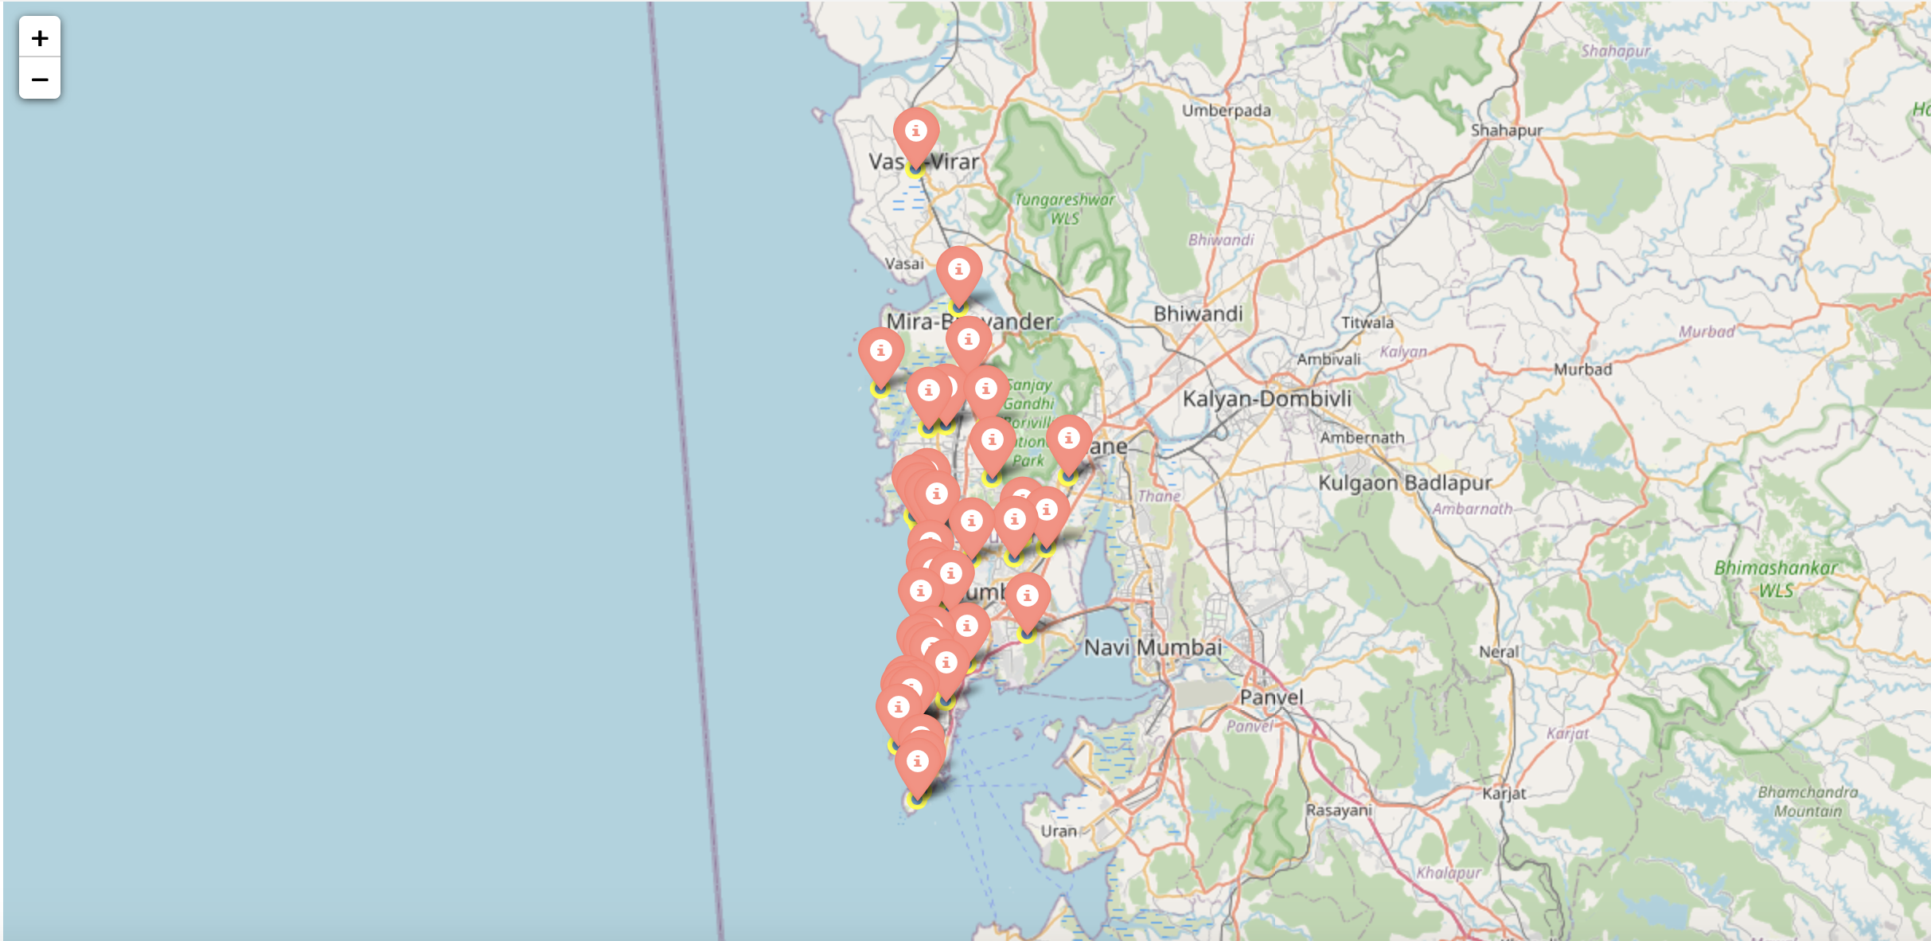

Figure 18: Neighbourhoods most suited for starting a new restaurant.

# Conclusion

The neighbourhoods in Mumbai, India have been systematically analysed to identify optimal locations for opening a new restaurant. Based on the analysis, neighbourhoods in cluster 1 have been recommended as the most suitable locations. Figure 18 illustrates these recommended neighbourhoods on a map.

**Considerations for Stakeholders and Investors:** While cluster analysis provides a solid foundation, stakeholders and investors are encouraged to further refine their decision-making process by considering additional factors such as transportation accessibility, legal requirements, and associated costs. These factors, although outside the scope of this project, play crucial roles in the success of restaurant ventures.

By leveraging this analytical approach, stakeholders can make informed decisions to maximize the potential success of their restaurant investments in Mumbai.

# Final Comments

**Note 1:** In order to view the code for this project, kindly refer to the notebook on the github repository at: